Risk Assessment Document for (insert Club/Region/NGB)

This risk assessment considers the potential for harm to come to children whilst they are in (insert Club/Region/NGB)’s care. This risk assessment precedes the Child Safeguarding Statement (Section 11 (1b) Children First Act 2015) which is developed following this risk assessment process. In accordance with the requirements of Section 11 (1) of the Children First Act 2015 the risk is of abuse and not general health and safety risk (covered under a separate H&S policy and risk assessment).
Section 11 (1) of the Children First Act 2015 states that where a person proposes to operate as a provider of a relevant service, he or she shall, within 3 months from the date on which he or she commences as such a provider —
- Undertake an assessment of any potential for harm to a child while availing of the service (in this section referred to as a “risk”).

Potential risk of harm to children |  | Likelihood of harm happening L-M-H | Required Policy, Guidance and Procedure document | Responsibility  Club/Region/National | Further action required …
CLUB & COACHING PRACTICES
Lack of coaching qualification |  | L | - Coach education policy  - Recruitment policy | Club/Region/National | Proof of qualification to be confirmed
Supervision issues |  | L | - Supervision policy  - Coach education policy | Club/Region/National | Ongoing review
Unauthorised photography & recording activities |  | L | - Photography and Use of Images policy | Club/Region/National | Ongoing review
Behavioural Issues |  | L | - Code of Conduct  - Safeguarding Level 1 (min)  - Complaints & Disciplinary policy | Club/Region/National | Ongoing review
Lack of gender balance amongst coaches |  | L | - Coach education policy  - Supervision policy | Club/Region/National | Ongoing review
No guidance for travelling and away trips |  | L | - Travel/Away trip policy  - Child Safeguarding Training | Club/Region/National | Ongoing review
Lack of adherence with misc procedures in Safeguarding policy (i.e. mobile, photography, transport) |  | L | - Safeguarding policy  - Complaints & disciplinary policy | Club/Region/National | Ongoing review
COMPLAINTS & DISCIPLINE
Lack of awareness of a Complaints & Disciplinary policy |  | L | - Complaints & Disciplinary procedure/policy  - Communications procedure | Club | Immediate action needed  Greater communication required
Difficulty in raising an issue by child & or parent  Reason: Covered above |  | L | - Complaints & Disciplinary procedure/policy  - Communications procedure |  | Review the communication/responsibilities of the procedure/policy as required
Complaints not being dealt with seriously |  | L | - Complaints & Disciplinary procedure/policy |  | Ongoing review
REPORTING PROCEDURES
Lack of knowledge of organisational and statutory reporting procedures |  | L | - Reporting procedures/policy  - Coach education policy  - Code of Conduct /Behaviour | NGB  MP  DLP | Make policies and procedures available  Include in Safeguarding Training (L1)  Include in Coach Education Training
No Mandated Person appointed |  | L | - Reporting procedures/policy | NGB | Publicise identity of Mandated Person  Train Mandated Person in their role
No DLP Appointed |  | L | - Reporting procedures/policy | NGB  Club | Train all DLPs  Publicise identity of DLPs
Concerns of abuse or harm not reported |  | L | - Reporting procedures/policy  - Child Safeguarding Training – Level 1 | MP  DLP | Include in Safeguarding Training (L1)  Publicise names of CCOs, DLPs, MP(s)  Publicise internal and external reporting procedures
Not clear who YP should talk to or report to |  | M | - Post the names of CCOs, DLPs and MP | CCO  DLP | Communicate in Club  Include in Safeguarding Training (L1)
FACILITIES
Unauthorised access to designated children’s play & practice areas and to changing rooms, showers, toilets etc. |  | L | - Supervision policy  - Coach education | NGB  Club | Clarify responsibilities before session starts
Unauthorised exit from children’s areas |  | L | - Supervision policy  - Coach education |  | Clarify responsibilities before session starts
Photography, filming or recording in prohibited areas |  | L | - Photography policy and use of devices in private zones |  | Enforce policy in private changing and wet areas
Missing or found child on site |  | L | - Missing or found child policy |  | Refer to policy and inform Gardai
Children sharing facilities with adults e.g. dressing room, showers etc. |  | L | - Safeguarding policy |  | Plan with facilities management to create a suitable child centred environment in shared facilities
RECRUITMENT
Recruitment of inappropriate people |  | L | - Recruitment policy | NGB  Club  CCO  Appropriate personnel | Ongoing review
Lack of clarity on roles |  | L | - Recruitment policy | Club | Check job description  Put supervision in place
Unqualified or untrained people in role |  | L | - Recruitment policy | Club | Check qualification  Ongoing review
COMMUNICATIONS AND SOCIAL MEDIA
Lack of awareness of ‘risk of harm’ with members and visitors | L |  | - Child Safeguarding Statement  - Training policy | National  Club  DLP  CCO | Communicate Child Safeguarding Statement
No communication of Child Safeguarding Statement or Code of Behaviour to  members or visitors | L |  | - Child Safeguarding Statement – display  - Code of Behaviour  - distribute | Club Executive  County Committee  DLP  Children’s Officer | Communicate Child Safeguarding Statement  Distribute Code or Sections as appropriate
Unauthorised photography & recording of activities | L |  | - Photography and Use of Images policy |  | Ongoing review
Inappropriate use of social media and communications by under 18’s | L |  | - Communications policy  - Code of conduct |  | Ongoing review
Inappropriate use of social media and communications with under 18’s | L |  | - Communications policy  - Code of conduct. |  | Ongoing review
GENERAL RISK OF HARM
Harm not being recognised | L |  | - Safeguarding policy  - Child Safeguarding Training |  | Ongoing review
Harm caused by  - child to child  - coach to child  - volunteer to child  - member to child  - visitor to child | L  L  L  L  L |  | - Safeguarding policy  - Child Safeguarding Training |  | Ongoing review
General behavioural issues | L |  | - Code of Conduct |  | Take disciplinary action where necessary  Sign code of conduct

Explanation of terms used:

- Potential risk of harm to children – these are identified risks of harm to children whilst accessing activities in the Club/Region/Province/NGB.
- Likelihood of harm happening – the likelihood of the risk occurring in the club/region/NGB measured by you as Low/Medium or High.
- Required Policy, Guidance and Procedure document – indication of the policy required to alleviate the risk.
- Responsibility – provider should indicate where the responsibility for alleviating the risk lies.
- Further action… - indicates further action that might be necessary to alleviate any risk ongoing.

This Risk Assessment document has been discussed and completed by Inishowen AC/Ulster/NGB as provider) on 31/03/2022
Signed: 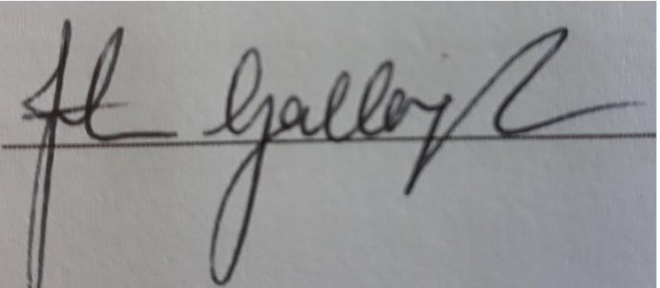 Signed: 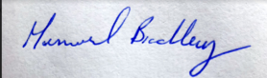
Name: Finbarr Gallagher Name: Muriel Bradley
Role: Chairperson Role: Club Children’s Officer
Date: 31/03/2022 Date: 31/03/2022

